 | REQUEST FOR NONCONFORMANCE REVIEW  (PROCURED MATERIAL)  Check one: Supplier Requested Albany Requested
NAMES AND ADDRESS (of originator) | Reference Number: |  |  | Date:
NAMES AND ADDRESS (of originator) | PURCHASE ORDER NO.  PURCHASE ORDER LINE NO.
SPECIFICATIONS AND ENGINEERING DRAWINGS AFFECTED
PART NUMBER |  | SPEC. NUMBER |  |  | REV
PART DESCRIPTION
DESCRIPTION OF NONCONFORMANCE
(provide quantity and serial numbers involved)
Should be:

Is Condition:

Root Cause and Corrective Action shall be documented on Appendix A and must be supplied as part of this request for nonconformance review
EFFECT ON DELIVERY SCHEDULE |  |  | EFFECT ON P.O. PRICE
ALBANY
FINAL DISPOSITION OF PRODUCT:

ENGINEERING APPROVAL REQUIRED:  Signature / Date: |  |  | QA APPROVAL REQUIRED:  Signature / Date:

Appendix 1
ATTACHMENT FORM - DETAIL CORRECTIVE ACTION PLAN
1.0 Previously Submitted Nonconformance (NC’s) Requests (if applicable)
Nonconformance Number and Item Number(s)
Note: If there are any previous NC’s with the same condition, you must list them all in the CA
If you have multiple NC’s referencing one CA, reference all.

2.0 Issue Description
- Fill out each field in Issue Description section of form.
- For All Items - Provide objective evidence such as Tools used (5Whys, Root Cause Tree, Fishbone Diagram, Pareto Chart, etc.)

Actual Condition
Actual Condition Field within the CA Description Window
What is happening? What is the physical evidence of the problem?
Where is the problem first observed? How was the problem discovered?
Provide specifics such as date, operator found, found via Read Across, etc.
How often is this problem occurring? What is the trend?
Where else does the problem occur?
Has this problem occurred before?
Is this a repeat issue? If yes, was the previous corrective action ineffective? Explain why ineffective
Why is this a problem? What is the impact of the problem?
What is affected by the problem?

3.0 Investigation Actions
- Fill out each Investigation Action
- For All Items - Provide objective evidence such as Tools used (5Whys, Root Cause Tree, Fishbone Diagram, Pareto Chart, etc.)

Investigation Action Item = Read Across
Have similar part numbers been evaluated for impact?
Will solution affect similar product beyond the immediate suspect population identified as being suspect due to common processes, material, drawing or supplier?
Description and Commit/Target Date
Ensure actions in implementation have a feasible Commit/Target Date

Investigation Action Item = Root Cause – Human Factors Investigation
Did human factors cause or contribute to the root cause?
If yes, explain which factors (reference human factors list)
Description and Commit/Target Date
Ensure actions in implementation have a feasible Commit/Target Date

Investigation Action Item = Initial Process Walk
Has a process walk been performed with a cross functional group including operators that perform the work?
Description and Commit/Target Date
Ensure actions in implementation have a feasible Commit/Target Date

3.0 Investigation Actions - continued
Investigation Action Item = Employee Interview
Have the employees involved been interviewed in effort to determine root cause?
Were the employees aware of the process / standard work requirements?
Were the employees adequately trained?
Do employees follow the planning as is and utilize tools call out?
NOTE: Investigation shall include the employees involved as well as their peers
Description and Commit/Target Date
Ensure actions in implementation have a feasible Commit/Target Date

Investigation Action Item = Documentation Review
Is there a documented process / standard work to follow to complete the task?
Summary of all documentation related to part number/process
Description and Commit/Target Date
Ensure actions in implementation have a feasible Commit/Target Date

Investigation Action Item = FAI Review
Has FAI review been conducted? Findings?
Description and Commit/Target Date
Ensure actions in implementation have a feasible Commit/Target Date

Investigation Action Item = Tech Help Submission
Has a Tech Help been submitted? If yes, please reference number
Description and Commit/Target Date
Ensure actions in implementation have a feasible Commit/Target Date

4.0 Root Cause Analysis
Root Cause Description
Root Cause Description Field within the CA Description Window

5.0 Corrective Action Plan
***Please Note – You can add additional actions beyond the template***
- Fill out each field in Corrective Action (CA) section of form.
- For All Items - Provide objective evidence and completion date(s) for all corrective actions.
- CA Item Descriptions to incorporate/include, When Applicable
  - Training record with full name(s) of trainees and instructor(s) and date(s) electronically or manually filled out. Related NC # and CA # should be included. Ensure all entries are legible. A digital or manual signature is required from the instructor as verification the training has been completed. Note: Training may not be acceptable as a 2nd time occurrence for the same defect.
  - Updated assembly operation sheet must be part of the submission of the DR. (Unless is a flight safety part)
  - Assembly Operation Sheet Review, Updated procedure/work instruction. (Attach as objective evidence both the old plans and updated plans) Have the procedures/standard work/work instructions been flowed out to the end user (or supplier sub tiers)?
  - Updated drawing/specification
  - Engineering Change (EC). ECs used as a sole long-term corrective actions.
  - Picture(s) showing the corrected condition.
  - Tooling/Equipment Changes. Other Technology opportunities?
  - Mistake-proof (e.g., go/no-go gage, fixture, tool, etc.) Aim for Level 1. Note: Is this a recurrence of a previous escape or corrective action? If so, is this Mistake Proof level higher than last?
    - Level (1) = Eliminate, prevent an error from occurring at the source
    - Level (2) = Detection, detect error as it is being made and
    - Level (3) = Mitigation, Prevent the defect from reaching the next operation.
  - If CA Changes Fit, Form or Function and/or Changes to the process (AOS/Work Instructions or Tooling/equipment) ensure a First Article Inspection is included as a Corrective Action Item capturing the changes and attached to the record.

5.0 Corrective Action Plan - continued
Corrective Action Description
Provide high level summary, (reference Cause Codes and Descriptions following)
Corrective Action Description Field within the CA Description Window

Action Item Title = Containment
Immediate actions to prevent reoccurrence
Description and Commit/Target Date
Ensure actions in implementation have a feasible Commit/Target Date
Action Item Type
Design M&P, M.E./Tooling, Operation, Production Control, Quality

Action Item Title = Short Term Corrective Action for Nonconformance
What immediate action is being taken to stop the non-conformance?
Description and Commit/Target Date
Ensure actions in implementation have a feasible Commit/Target Date
Action Item Type
Design M&P, M.E./Tooling, Operation, Production Control, Quality

Action Item Title = Short Term Corrective Action for Non-Detection
What immediate action is being taken to prevent non-detection?
Description and Commit/Target Date
Ensure actions in implementation have a feasible Commit/Target Date
Action Item Type
Design M&P, M.E./Tooling, Operation, Production Control, Quality

5.0 Corrective Action Plan - continued
Action Item Title = Long Term Corrective Action for Nonconformance
What long term action is being taken to stop the non-conformance?
Description and Commit/Target Date
Ensure actions in implementation have a feasible Commit/Target Date
Action Item Type
Design M&P, M.E./Tooling, Operation, Production Control, Quality

Action Item Title = Long Term Corrective Action for Non-Detection
What long term action is being taken to prevent non-detection? i.e. New FAI
Description and Commit/Target Date
Ensure actions in implementation have a feasible Commit/Target Date
Action Item Type
Design M&P, M.E./Tooling, Operation, Production Control, Quality

Cause Codes and Descriptions
- NOTE: Operator Error is generally NOT acceptable. State if the employee truly has all required training, methods, processes and tools and is found to be noncompliant.
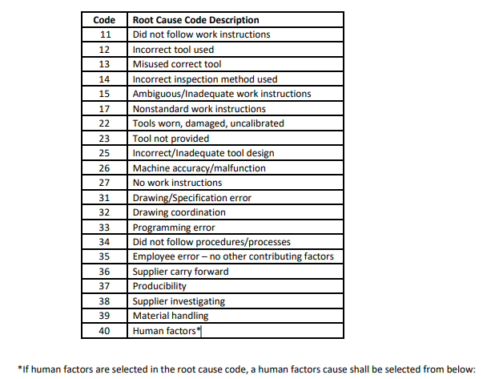
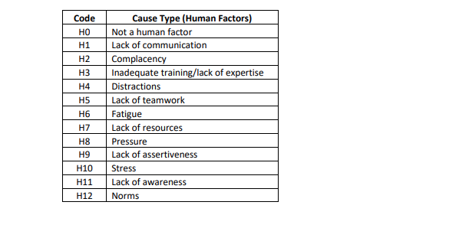

CA Codes and Descriptions

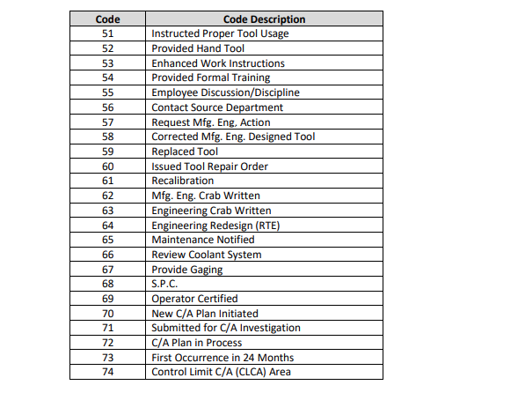
APPROVAL

